- Challenge Name and Category: FLAG HUNTERS (Reverse Engineering)

- Difficulty/Points: Easy

- Description: Lyrics jump from verses to the refrain kind of like a subroutine call. There's a hidden refrain this program doesn't print by default. Can you get it to print it? There might be something in it for you.The program's source code can be downloaded here.Connect to the program with netcat: $ nc verbal-sleep.picoctf.net 62975

- Flag: picoCTF{70637h3r_f0r3v3r_0099cf61}

- Solution/Walkthrough: The first step was to access the program using net cat by issuing the command $ nc verbal-sleep.picoctf.net 62975. This produces source code and lyrics to a song in Python.
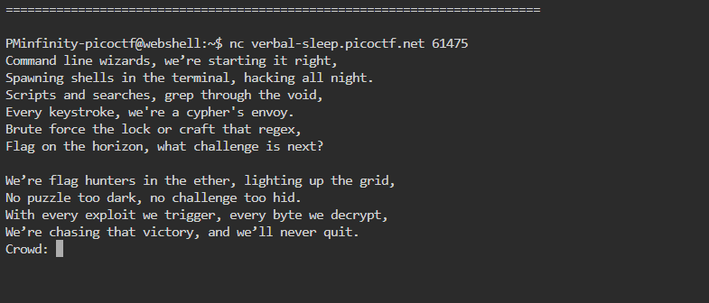Immediately at the beginning of this source code, we can see a secret intro that does not get mentioned if you were to command wget lyric-reader.py. This block of code ends with + flag + ‘\n’. At the end of this source code there is an unsanitized input for “crowd”. This struck me as suspicious, and I had a feeling that I would need to come back to it. The next bit of revealing information was seeing the RETURN function appear several times throughout the code. In Python the RETURN function will force the reader to read any specific line.
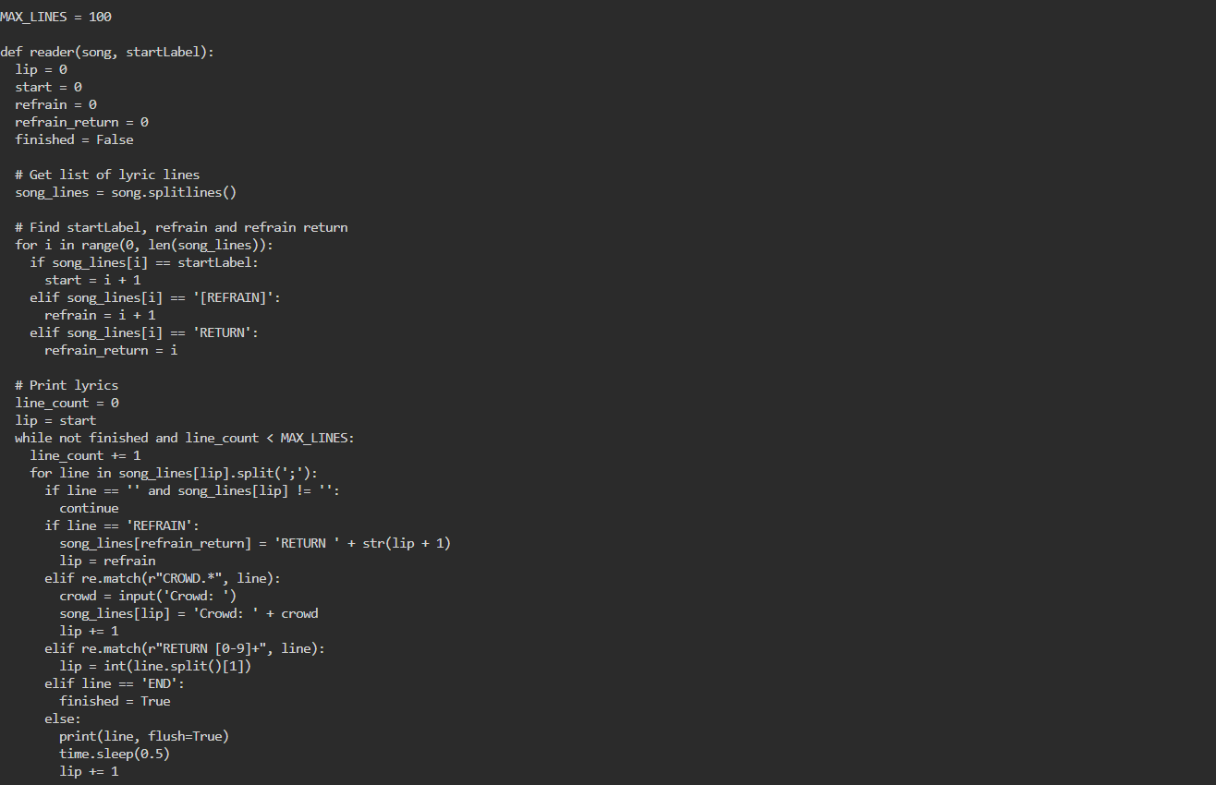
Using this information, we can use the command some_string;RETURN 0 after net catting into the program. This command is issues when prompted an input from crowd. This reveals and prints the flag into the lyrics after “crowd” was referenced.
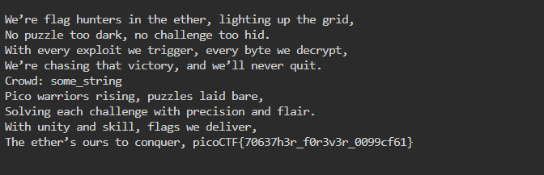

- Tools Used: web shell, Python

- Initial Reconnaissance: After accessing the program, I recognized Python rather quickly and confirmed it by downloading the file which ended in .py. The input for “crowd” was interesting as well.

- Hypothesis Formulation: What input do I need to discover the hidden information in this Python code?

- What Worked vs. What Didn't: Being familiar with python I knew a little bit about what to look for. At first, I would attempt to use the RETURN 0 function instead of the “some_string;RETURN 0”. The input after “crowd” stalled me for a bit as well.

